DATA ANALYST INTERNSHIP TASK 3

HERE IS LINK - https://public.tableau.com/views/Bookssalesfinscialdashboard/Dashboard1?:language=en-US&:sid=&:redirect=auth&:display_count=n&:origin=viz_share_link

BOOKS SALES FINANCIAL DASHBOARD ANALYSIS

Overview
To analyze book sales data using an interactive Tableau dashboard that helps stakeholders gain insights into:
- Sales performance by genre, author, publisher
- Trends across years
- Profitability and unit sales
- Popularity of books and authors

Tasks Completed
- Total Gross Sales
- Total Publisher Revenue
- Total Units Sold
- Average Book Rating
- Top Performing Genre (by Sales)
Displayed as summary cards at the top of the dashboard.

Visualizations/Charts Used:
- Gross Sales by Genre
→ Horizontal bar chart showing total sales across each genre
- Units Sold by Author
→ Bar chart to identify most popular authors by volume
- Publisher Revenue Over Years (Time Series)
→ Line chart to track revenue growth by year
- Top 10 Books by Sales
→ Bar chart to rank highest-grossing books
- Average Book Rating by Genre
→ Bubble/Bar chart to visualize reader feedback by category
- Language-wise Book Sales
→ Pie chart to see distribution of sales across different languages
- Sales by Publisher
→ Tree map to compare different publishers by revenue
- Sales Rank vs Revenue Scatter Plot
→ See how sales rank correlates with revenue
- Top Authors by Publisher Revenue
→ Bar chart of highest-earning authors
- Units Sold by Year
→ Area chart to track growth in books sold year-wise

Design Features:
- Clean and consistent color theme
- Interactive cards for KPIs
- Easy navigation with filters
- Visual hierarchy with important insights on top
- Created a horizontal bar chart for Sales and Profit by Sub-Category.

- Tableau Public (for dashboard creation and publishing)
- Google docx. For report making.

Conclusion
The data shows that a few top genres and authors dominate book sales and revenue. English-language books clearly perform best, with some non-English markets showing potential. There is a clear correlation between good author ratings and sales rank, though exceptions exist. Pricing is mostly mid-range, catering to the average reader, and publisher reputation plays a significant role in sales.

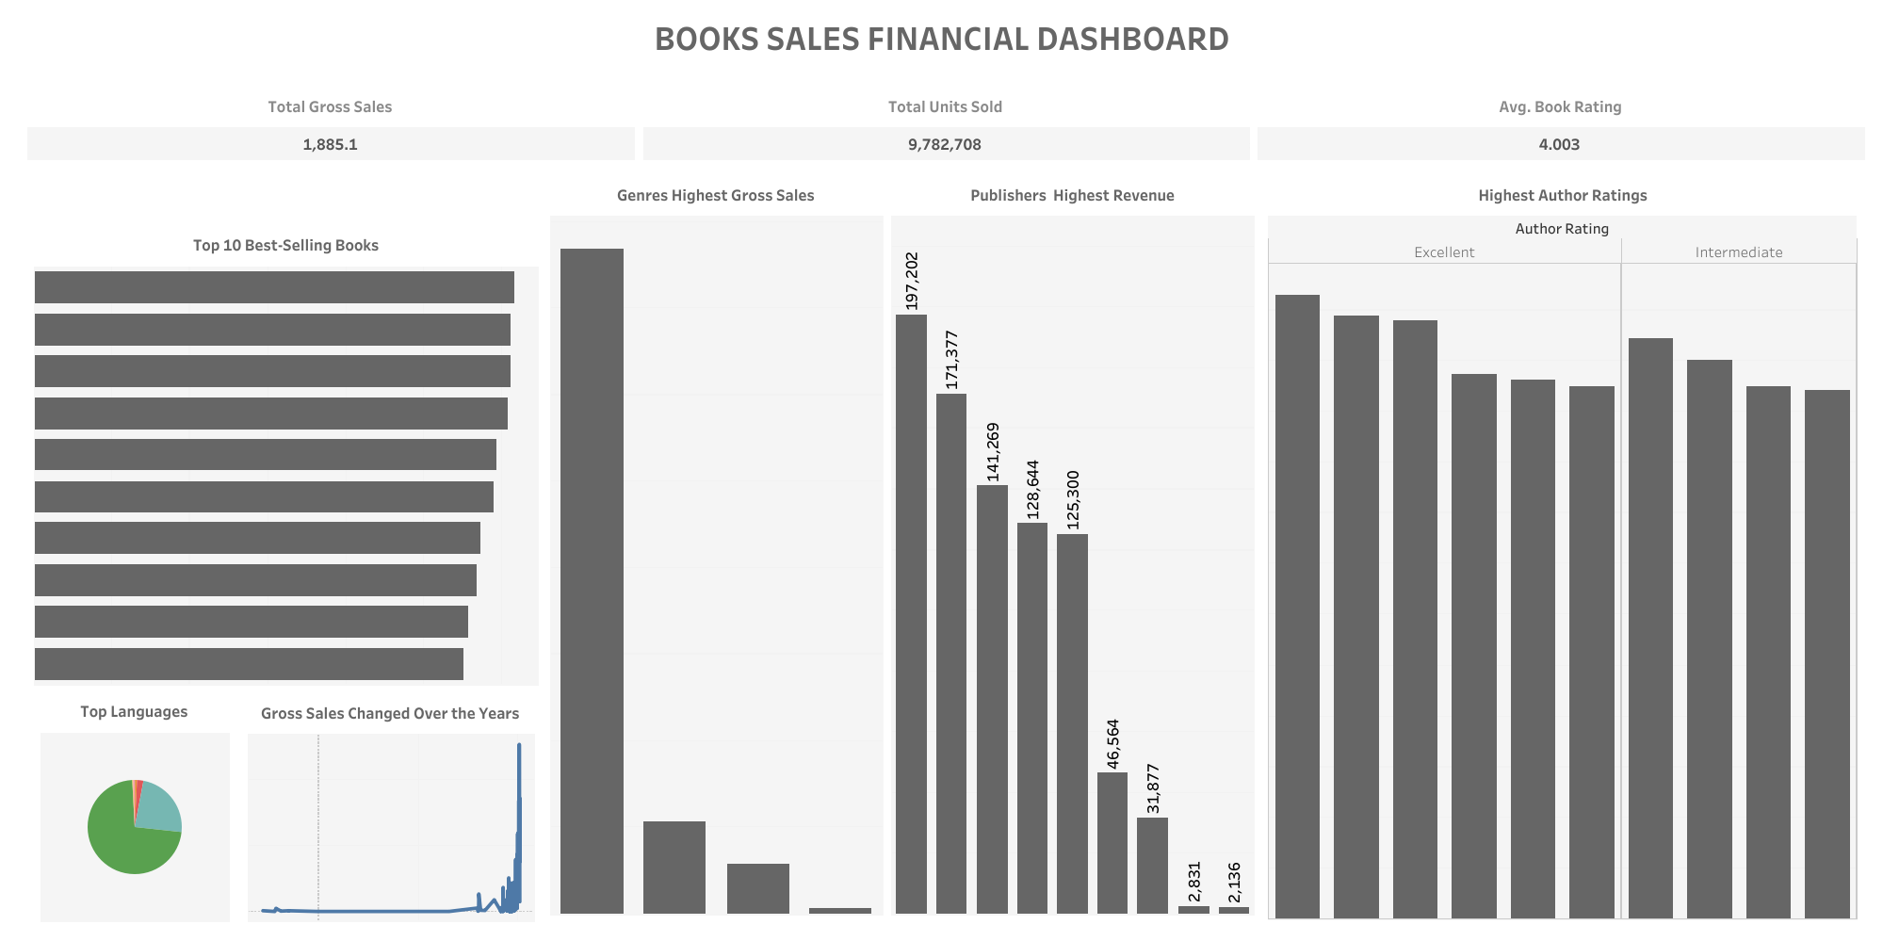

End

